Ethan Britton

CS 6030

Fall 2021

**Final Project Report**

**Description of Problem:**

When analyzing bug reports for apps, developers can often feel very overwhelmed. A lot of common apps for Android and iOS have thousands if not hundreds of thousands of bug reports. This can often lead to misleading information or a complete lack of information as developers will often skip reading the bug reports all together. This is the problem that is faced in the creation of this app. This app aims to classify bug reports into different categories for developers looking to target certain areas of their apps. This will help developers tremendously with fixing specific issues and allow them to save tons of time.

**Results:**

The app works by taking a folder of bug reports and classifying them into either functional or non-functional bugs. Below are screenshots of a sample upload and results file generated by the app. Graphical user interface, application, table

**Figure 1. Sample Input Folder**

**Figure 2. Sample Output Structure**

**Figure 3. Sample Output Folder**

Figure 1 shows the file structure of an example input for this app. The folder that was uploaded contains several text files of bugs that are labelled as Functional or Nonfunctional for the purpose of testing. In the real world these text files do not need to be labelled. Figure 2 shows the sample output structure of the file returned by the app. This contains 3 folders identified as functional, nonfunctional, or unknown. The text files from the input are classified and moved into the corresponding folders as illustrated in Figure 3. Below are screenshots of a functional and nonfunctional bug report example that were used in the test.

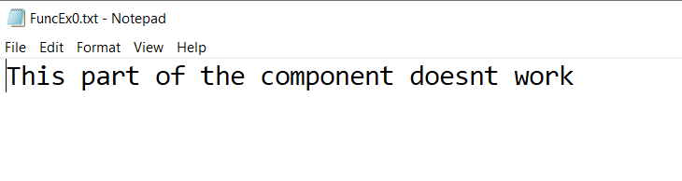

**Figure 4. Functional Bug Report Example**

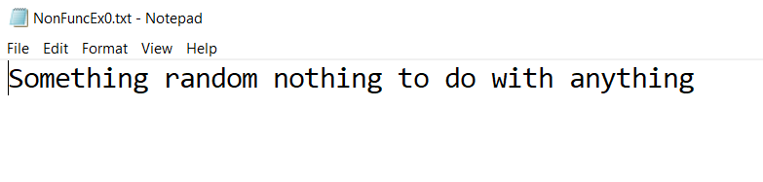

**Figure 5. Non-Functional Bug Report Example**

Figure 4 clearly relates to a functional bug report while Figure 5 clearly does not. The app classifies these both correctly and returns the desired result. Some improvements for this app would be adding other categories of classification for the app besides just functional bug reports. These could include performance, security and many more. When run with multiple test inputs, the app classifies the bug reports at an average accuracy of 85%. These results are good given the setbacks with limited data for training the model. The training data used for the model was also manually labelled and could contain some errors. Overall, the app works very well for its specific goal and not well for any other general goal. Hopefully it will be able to offer developers a tool to aid with bug report analyzing.